17th INTERNATIONAL WORKSHOP ON ELECTRODEPOSITED NANOSTRUCTURES
November 4th-7th, 2026. Miraflores de la Sierra (Madrid) Spain

FIRST CIRCULAR
Dear colleagues, dear EDNANO friends,
We are proud to announce the 17th edition of the EDNANO Workshop, which will take place on November 4th-6th, 2026, in Miraflores de la Sierra (Madrid) Spain, at La Cristalera. This unique venue is a corporate retreat set in the heart of nature, offering an inspiring and tranquil environment.

As part of the social program, participants will be offered an optional cultural excursion on November 7th to Madrid’s Royal Palace, one of the largest and best-preserved royal palaces in Western Europe. The Royal Palace of Madrid is a baroque construction with more than 3000 rooms and works by great artists such as Caravaggio, Velázquez and Goya.

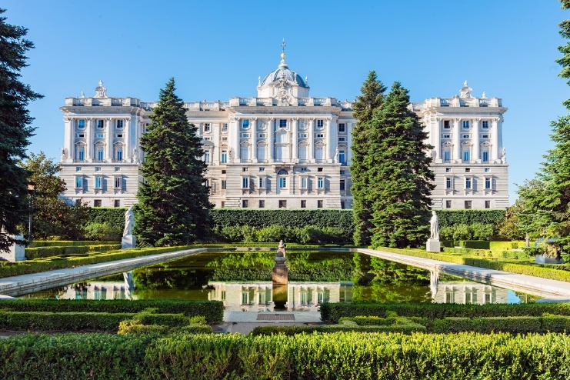

Abstract submission and registration open: March 2026
Abstract submission deadline: early July 2026
Notification of abstract acceptance and presentation type: early September 2026
Registration deadline: middle September 2026

Further details (fees, accommodation, preliminary program) will be given in the second circular. A dedicated conference website is under construction

